# Instructions

The web development team has requested that you create a directory structure and some placeholder files for their new web site application on the CentOS server you created for them previously. Please create the following directories:

/development

/development/website

/development/website/images

/development/website/js

Also, please create a file called index.html within the website directory and enter the following text:

<h1>This site is currently under construction</h1>

<img src=”./images/underconstruction.jpg”>

Finally, search the internet for a jpeg (image) depicting “under construction”. Download the file to the server. Move this file to the images directory and rename it to underconstruction.jpg.

Test the file by entering the command:

firefox /development/website/index.html

# Screenshots

Paste the required screen shots under each description.

1. Show a directory listing of the /development and /development/website directories

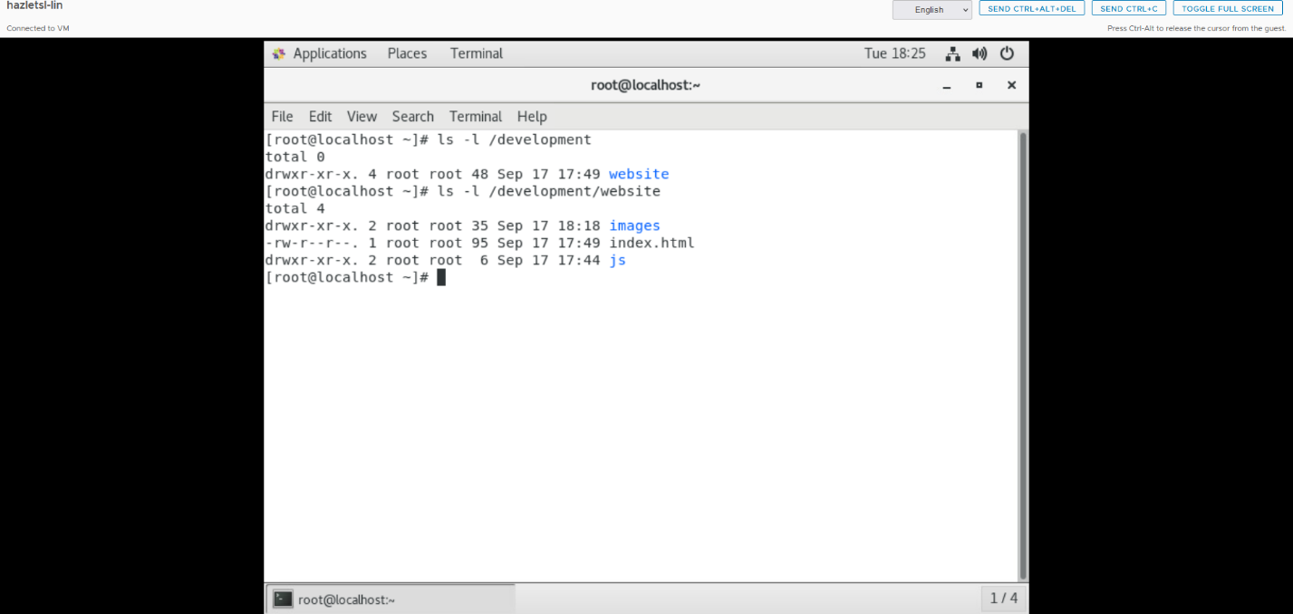

1. Open the index.html file with ‘vi’ and show the text required

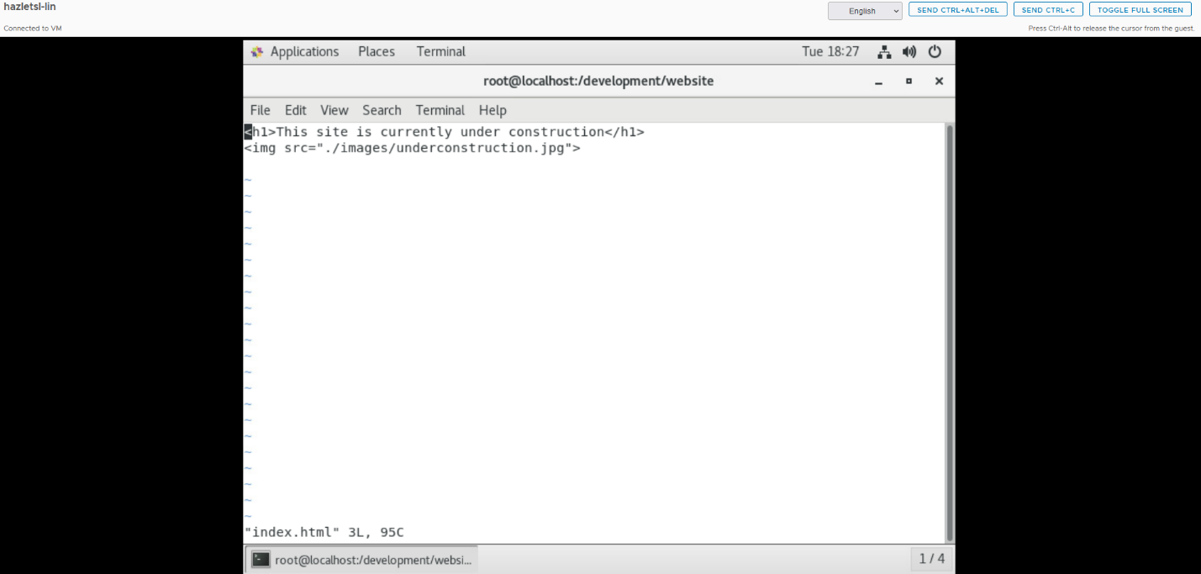

1. Take a screen shot showing the index.html file in Firefox from your test

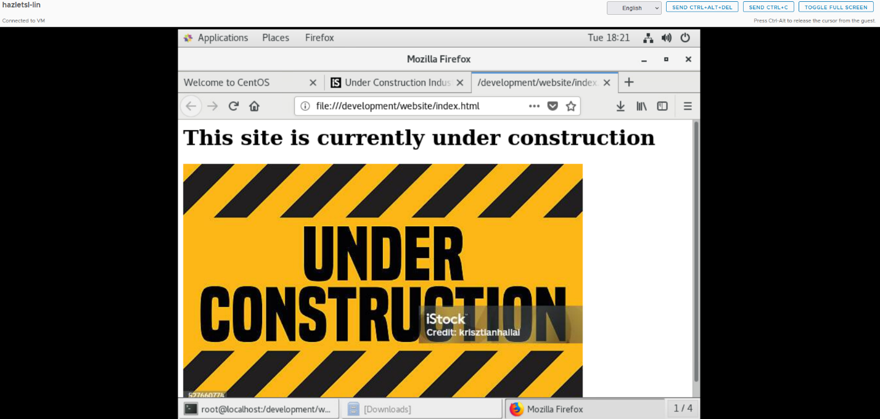

# Documentation

Record and explain all the steps you took to complete the task. Include any commands used, screen shots showing GUI interfaces, or any other information that would help you recreate the task.

**Note: You will be allowed to use this documentation to help you complete future assignments.**

* Created Directories:

mkdir /development

mkdir /development/website

mkdir /development/website/images

mkdir /development/website/js

* Created and edited the index.html file:

vi /development/website/index.html

* Went onto the internet and found a under construction image. Renamed it to underconstruction.jpg. put the file into the Downloads folder
* Moved underconstruction.jpg to correct directory:

mv ~/Downloads/underconstruction.jpg /development/website/images/

* Tested the file in Firefox:

firefox /development/website/index.html &

* Listed directory contents:

ls -l /development

ls -l /development/website